**UPLOADING THE FILE PATHS:**

The below code is run to clone the Github repository to Google Colab folder,

!git clone <https://github.com/Karthika-ai/Vehicle-Detection-and-Tracking-Using-Kalman-Filter.git>

Then, all the folders in GitHub are cloned to the files folder in Google colab.

1. **Loading the path of image folder into ‘cwd’:**



**Steps:**

Copy the below path and paste in cwd:

1. **Adding the pre-trained model’s folder path in detect_model_name:**

**Steps:**

Copy the below path and paste in detct_model_name:

1. **Adding image folder path in class Tracker()at below location: everything before ‘/*’**

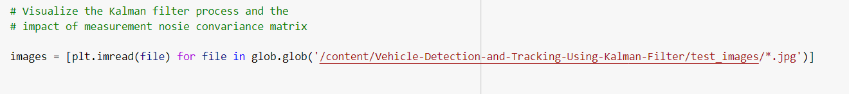

**Steps:**

Copy the below path and paste in detct_model_name

